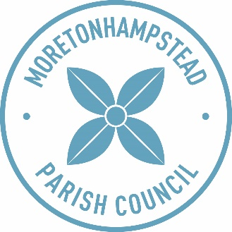

Meeting of the Parish Council to be held on Tuesday 3rd December 2019 at 7.00pm at the Community Club, Moretonhampstead, for the purposes of transacting the following business:

AGENDA

Public Session

No | Agenda | Councillor/Speaker
1. | To accept apologies for absence | Chairman
2. | To receive declarations of interest in items on the agenda and requests for dispensations | Chairman
3. | To approve the draft minutes of the meeting of the Parish Council held on 5th November 2019 (copy attached) | Chairman
4. | To receive the County Councillor’s Report | County Cllr Jerry Brook
5. | Matters arising not on the agenda – for report only  - Following on from Novembers meeting and the member of the public’s concern over the grass cuttings from the wild flower area in the churchyard not being collected, Bio Blitz have raked the area and collected the grass cuttings  - 175/2019 – Xmas light switch on. Road closure signs are now in place.
6. | To note matters under the Chairman’s discretion | Chairman
7. | To receive the District Councillor’s Report | District Cllr Mike Jeffery
8. | To receive the Open Spaces monthly report | Cllr Paul Dodd
9. | To consider the following planning applications:  - 0516/19 – Proposed: Replacement windows to first and second windows of front elevation at 1 Ford Street, Moretonhampstead  - 0524/19 – Proposed: Construction of proposed new outbuilding for use as ancillary accommodation to main dwelling at Blackingstone Farm, Moretonhampstead  - 0515/19 – Proposed: Erection of side extension at Yarningale, Moretonhampstead  - 0481/19 – Proposed: New farmstead comprising farm buildings, yard and temporary agricultural workers dwelling together with alterations to public right of way arrangements at Cranbrook Linhay Farm, Moretonhampstead | Chairman / Cllr Bas Payne
10. | To receive the draft minutes of the meeting of the finance & Policy committee held on 19th November 2019 and to agree the following recommendations:  - Recommendation to full council to approve the attached draft budget 2020/21 and precept request.  - Recommendation to full council to approve the following policies:  - Data Protection Privacy Policy  - Health and Safety Policy | Chairman / Cllr Nicky Cardew
11. | To review cemetery regulations and cost (current copy attached) | Chairman
12. | To consider the draft Risk Assessment Policy (copy attached) | Chairman / Cllr Nicky Cardew
13. | To receive the report of the Internal Financial Regulator | Cllr Bas Payne
14. | To approve the list of payments (to be tabled at the meeting) | Chairman
15. | To receive correspondence (attached) and to agree any response:  - Letter from Emma Wotton regarding a tree blocking the waterway adjacent to the sewage works.  - DNPA response to MPC complaint relating to 0489/06 (Former Gales Saw Mills, Court Street, Moretonhampstead): consent to use of cement fibre cladding on elevations facing Court Street | Chairman
16. | To receive reports from Councillors with particular responsibilities | Councillors
Public Session

Date: 27th November 2019 Signed: Samantha Parkin (Parish Clerk)

