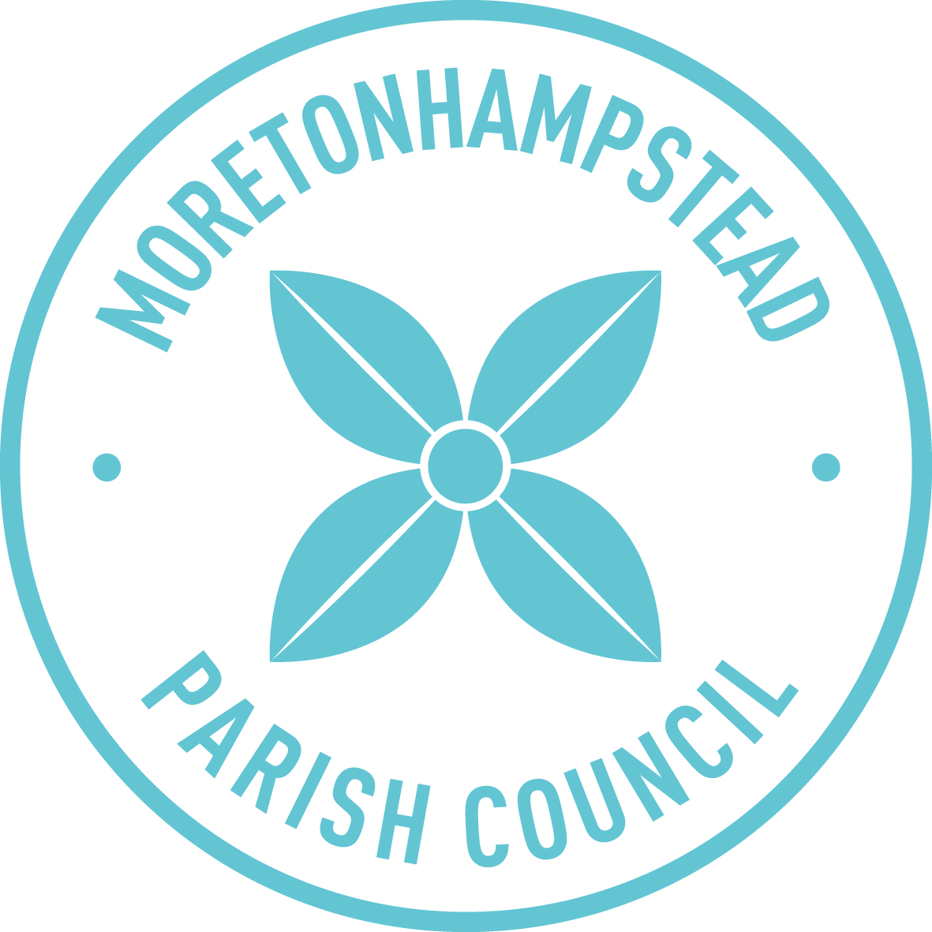

Moretonhampstead Parish Council

Local Plan Response Survey: What’s important to you?

CONSULTATION DRAFT
May-July 2018

The Dartmoor National Park Authority (DNPA) – which decides on planning applications across the National Park including Moreton, is updating its Local Plan. They will produce a draft in June, and we have until the end of September to comment. The local plan is important for all of us because when it comes into effect, in 2020, it will have a very large effect on planning policy during the plan period, which is the next 15 years until 2035. Housing is a major focus of the Local Plan, but its scope is much wider than just housing.

It is now 12 years since we last carried out a survey to find out more about what’s important to you – what you care about, what you feel about different aspects of living in Moreton, and what you would like to try to change. The reason for doing this now is that it will give us greater confidence in responding to the draft local plan. We need to understand what you think. DNPA are likely to take more notice of what we say if we are able to show that it is based on good information. It will also help us over the next few years in what we do, and what priority we give to different matters.

Why aren’t we doing this after the draft plan is published? The answer is simple – there isn’t enough time to do a proper survey between the time DNPA publishes its draft plan and when comments are due. Once the draft plan has been published, we would welcome your comments on it; and we will put our intended response on the PC website and on the PC notice board by mid-August, so that you can comment on the response at that point.

How much difference will it make? The Parish Council has limited powers and resources, and can’t therefore do much on its own; but we can do a little, and, probably just as important, we will have much more hope of influencing DNPA, Teignbridge District Council (TDC) and Devon County Council (DCC) if what we say to them is sensible and clearly based on public opinion.

Please respond to this survey – it will only be useful and carry weight with DNPA, TDC and DCC if we get a good response. And please don’t send only one reply if there is more than one person in your household: you may not feel the same way about everything, and it is important that everyone has their say. Your views matter.

Spare forms are available from the Information Centre and from the Parish Council office (in Green Hill). They will also be available from an information table in front of the Co-op between 10-12 on Saturdays June 23, June 30, July 7 and July 14 (unless the weather is unkind). Forms can also be downloaded from the PC website http://visitmoretonhampstead.co.uk/living-here/parish-council/

Filling the form in shouldn’t take more than 5-10 minutes; you are very welcome to add your reasons and/or further comments in the spaces provided, and continue on another page if you need more space.

PLEASE RETURN BY SUNDAY 15 JULY

Further background information – especially on how Moreton has developed and changed over the last 100 years – will be available on the website, and from the parish office and the information centre
SECTION A – General questions about what’s important.
 | Please tick boxes as appropriate - feel free to tick as many boxes as you want. | How important is this for the town? |  |  | How well is Moreton doing at the moment? |  |  | What do you think we should be trying to do?-Change/improve/conserve.  Details would be helpful - please continue on another sheet if you need more space | If you think we need to change or improve this, how high a priority should this be?  Please think about how important you think it is and how difficult it is likely to be.
 |  | Very important | Important | Not important | Excellent | OK | Poorly |  | High priority | Medium priority | Low  priority
1 | The traditional/historic feel of the town. Church, almhouses and other listed buildings.
2 | Attractiveness of the town as seen  when approaching it.
3 | Views from the town to the woods, hills and natural environment.
4 | Open spaces within the town  such as the Sentry, and the Square.
5 | Health and welfare provision  such as GP surgery, dentist, osteopath, acupuncture, care home.
6 | The range of local shops.
7 | The range of services in the town  such as mechanics, hairdresser,  solicitor, Post Office.
8 | Sports and leisure facilities such as Sports Centre, swimming pool, skateboard park, cycle track.
9 | Cultural facilities such as Greenhill and Bowring Library.
10 | Availability and suitability of halls etc.for events and social gatherings  such as Parish Hall, Community Club and Sports Centre.
11 | Hotels, pubs, restaurants and cafes.
12 | Clubs & societies, community activities and volunteering opportunities.
13 | Places of worship.
14 | Allotments.
15 | Availability of information about the  town and what’s going on in the town such as News in Moreton, Information Centre and website.
16 | Local business activity and employment opportunities.
17 | Being able to live and work in the town.
18 | Range, availability and affordability of housing to buy.
19 | Range, availability and affordability of private and social housing to rent.
20 | Condition of public spaces and facilities such as pavements, roads, toilets etc.
21 | Traffic congestion.
22 | Availability of car parking for local  residents and visitors.
23 | Public transport and transport links.
24 | Facilities/activities for pre-school  children.
25 | Primary schooling.
26 | Secondary schooling.
27 | Out-of-school clubs/ activities.

SECTION B – Specific questions / hot topics - mainly to be added after consultation.

Possible example:

B1 Rate of growth? Since 1945, Moreton has grown at about 25-30 new homes every 10 years.

How fast do you think Moreton should grow in the next 50 years? (please tick one option) | Not at all | Slower than since 1945 | At about the same rate | Faster (e.g. 50-60 new homes / 10 years) | Much faster (e.g. 100+ new homes every 10 years) | Don’t know

SECTION C: Information about you.

This section is optional – but would help us to know how representative the results are, and to be able to contact you about your replies if you are willing to be contacted. Personal information will not be passed on to others in any circumstances.

How much of the year do you live in the parish?  (please tick one option) | Most of the year (6+ months) | Less than half the year (1-5 months) |  | Less than 1 month |  | None
Which part of the parish do you live in?  (please tick one option) | Live in the town |  | Live in the parish but outside the town |  | Live outside the parish
Your age?  (please tick one option) | under 18 | 18-29 |  | 30-59 |  | 60+
Your gender  (please tick one option) | Female |  |  | Male
Your name?

Are you willing to be contacted about your comments/suggestions? | Please don’t contact me. | Please feel free to contact me. Preferred means:  e-mail:  Telephone  Address:

Please:

- post completed forms to The Parish Clerk, Parish Office, Green Hill, Fore Street,
Moretonhampstead TQ13 8LL in an envelope marked “Local plan survey”, or
- hand completed forms in at the Information Centre, in an envelope marked “Local plan survey” , or
- e-mail your response to moretonhampsteadpc@tiscali.co.uk, with “Local plan survey” in the subject
line.

by Sunday 15 July

For further information as things develop, please see the PC website, and the PC noticeboard; updates will also be published in News in Moreton.

